Introduction

Iceland is, due to its beautiful landscape, a very attractive country for visitors. The number of tourists travelling there is a rising tide but the question of how to accommodate them is also becoming increasingly important. Our project group was dealing with this topic and compared the most current types of accommodation in terms of prices, capacity, location and seasons. During our research we came to the decision that a table and a few explaining lines would be the best solution to present the relevant facts.

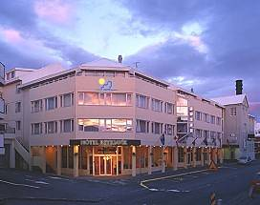

Hotels and Guesthouses
There are hotels and guesthouses to suit all tastes and budgets, from the most luxurious to the simple and sufficient.

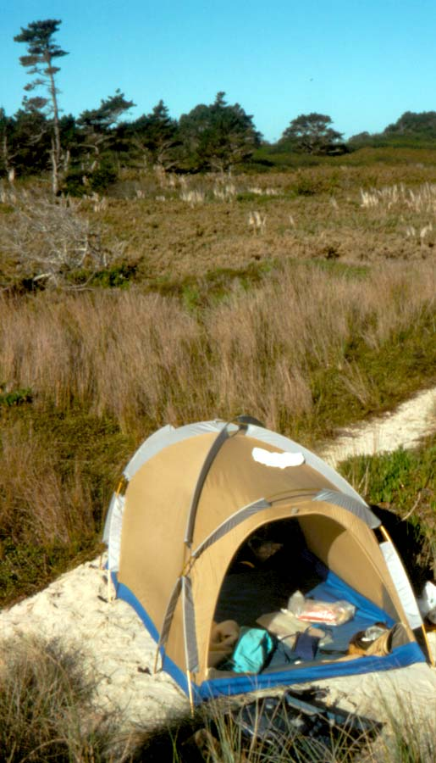
Camping
Camping in Iceland is very popular. In the mountain areas it is sometimes the only accommodation available. It may be interesting that camping is not only possible on official sites, but nearly everywhere in Iceland.

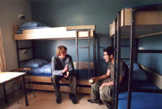
Youth and Family Hostels
As everywhere in the world hostels offer cheap and proper accommodation. Breakfast is optional and these houses are a comfortable solution for tourists who don’t want to spend a lot of money but want to see a lot of the island.

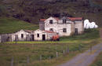
Farmhouses
This is a very booming branch of Icelandic tourism and it is very popular because it’s a good opportunity to get to know some Icelanders personally. Visitors can go horseback riding, collecting sheep, fishing, hunting and go on glacier tours.

